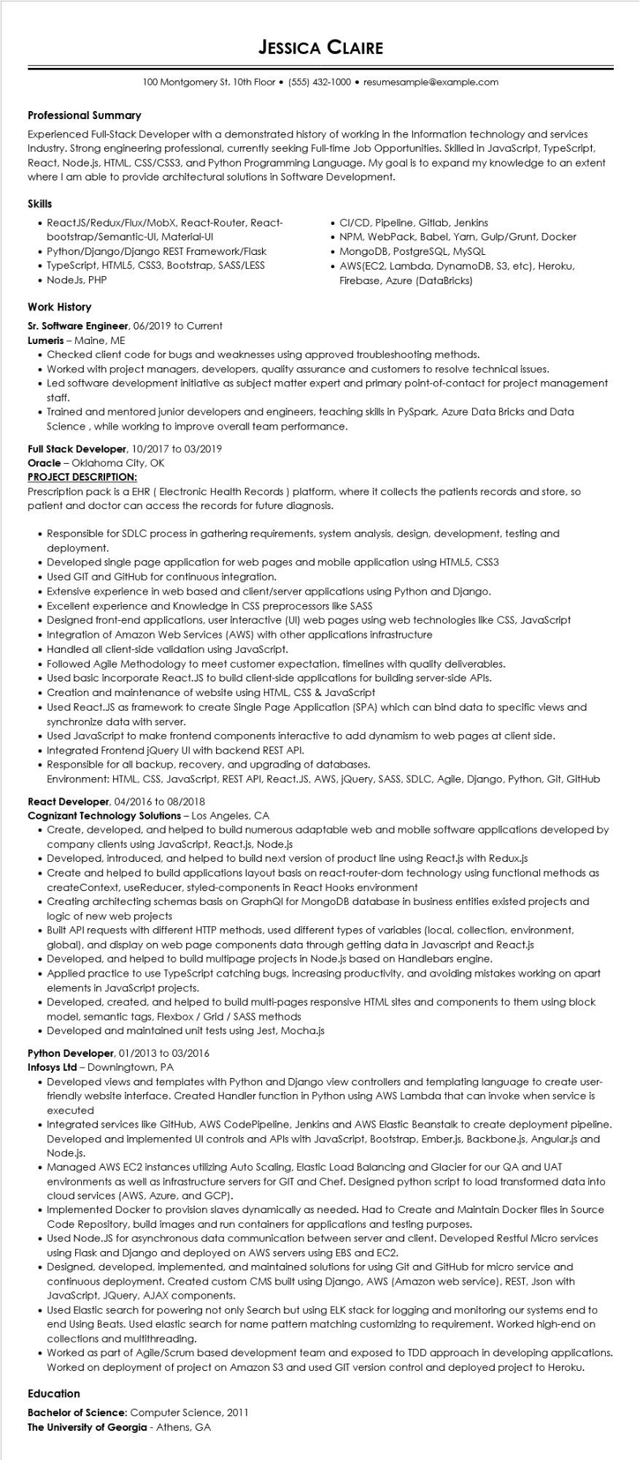
Professional Summary
JESSICA CLAIRE
100 Montgomery St. 10th Floor⚫ (555) 432-1000⚫ resumesample@example.com
Experienced Full-Stack Developer with a demonstrated history of working in the Information technology and services Industry. Strong engineering professional, currently seeking Full-time Job Opportunities. Skilled in JavaScript, TypeScript, React, Node.js, HTML, CSS/CSS3, and Python Programming Language. My goal is to expand my knowledge to an extent where I am able to provide architectural solutions in Software Development.
Skills
• ReactJS/Redux/Flux/MobX, React-Router, React- bootstrap/Semantic-UI, Material-UI
• Python/Django/Django REST Framework/Flask
• TypeScript, HTML5, CSS3, Bootstrap, SASS/LESS • NodeJs, PHP
Work History
Sr. Software Engineer, 06/2019 to Current
Lumeris - Maine, ME
• CI/CD, Pipeline, Gitlab, Jenkins
• NPM, WebPack, Babel, Yarn, Gulp/Grunt, Docker
• MongoDB, PostgreSQL, MySQL
AWS(EC2, Lambda, DynamoDB, S3, etc), Heroku, Firebase, Azure (DataBricks)
• Checked client code for bugs and weaknesses using approved troubleshooting methods.
• Worked with project managers, developers, quality assurance and customers to resolve technical issues.
• Led software development initiative as subject matter expert and primary point-of-contact for project management staff.
• Trained and mentored junior developers and engineers, teaching skills in PySpark, Azure Data Bricks and Data Science, while working to improve overall team performance.
Full Stack Developer, 10/2017 to 03/2019
Oracle - Oklahoma City, OK
PROJECT DESCRIPTION:
Prescription pack is a EHR (Electronic Health Records) platform, where it collects the patients records and store, so patient and doctor can access the records for future diagnosis.
• Responsible for SDLC process in gathering requirements, system analysis, design, development, testing and deployment.
• Developed single page application for web pages and mobile application using HTML5, CSS3
• Used GIT and GitHub for continuous integration.
• Extensive experience in web based and client/server applications using Python and Django.
• Excellent experience and Knowledge in CSS preprocessors like SASS
• Designed front-end applications, user interactive (UI) web pages using web technologies like CSS, JavaScript
• Integration of Amazon Web Services (AWS) with other applications infrastructure
• Handled all client-side validation using JavaScript.
• Followed Agile Methodology to meet customer expectation, timelines with quality deliverables.
• Used basic incorporate React.JS to build client-side applications for building server-side APIs.
• Creation and maintenance of website using HTML, CSS & JavaScript
• Used React.JS as framework to create Single Page Application (SPA) which can bind data to specific views and synchronize data with server.
• Used JavaScript to make frontend components interactive to add dynamism to web pages at client side.
• Integrated Frontend jQuery UI with backend REST API.
• Responsible for all backup, recovery, and upgrading of databases.
Environment: HTML, CSS, JavaScript, REST API, React.JS, AWS, jQuery, SASS, SDLC, Agile, Django, Python, Git, GitHub React Developer, 04/2016 to 08/2018
Cognizant Technology Solutions - Los Angeles, CA
• Create, developed, and helped to build numerous adaptable web and mobile software applications developed by company clients using JavaScript, React.js, Node.js
• Developed, introduced, and helped to build next version of product line using React.js with Redux.js
• Create and helped to build applications layout basis on react-router-dom technology using functional methods as createContext, useReducer, styled-components in React Hooks environment
• Creating architecting schemas basis on GraphQI for MongoDB database in business entities existed projects and logic of new web projects
• Built API requests with different HTTP methods, used different types of variables (local, collection, environment, global), and display on web page components data through getting data in Javascript and React.js
• Developed, and helped to build multipage projects in Node.js based on Handlebars engine.
Applied practice to use TypeScript catching bugs, increasing productivity, and avoiding mistakes working on apart elements in JavaScript projects.
• Developed, created, and helped to build multi-pages responsive HTML sites and components to them using block model, semantic tags, Flexbox / Grid / SASS methods
• Developed and maintained unit tests using Jest, Mocha.js
Python Developer, 01/2013 to 03/2016
Infosys Ltd - Downingtown, PA
• Developed views and templates with Python and Django view controllers and templating language to create user- friendly website interface. Created Handler function in Python using AWS Lambda that can invoke when service is executed
• Integrated services like GitHub, AWS CodePipeline, Jenkins and AWS Elastic Beanstalk to create deployment pipeline. Developed and implemented UI controls and APIs with JavaScript, Bootstrap, Ember.js, Backbone.js, Angular.js and Node.js.
• Managed AWS EC2 instances utilizing Auto Scaling, Elastic Load Balancing and Glacier for our QA and UAT environments as well as infrastructure servers for GIT and Chef. Designed python script to load transformed data into cloud services (AWS, Azure, and GCP).
• Implemented Docker to provision slaves dynamically as needed. Had to Create and Maintain Docker files in Source Code Repository, build images and run containers for applications and testing purposes.
• Used Node.JS for asynchronous data communication between server and client. Developed Restful Micro services using Flask and Django and deployed on AWS servers using EBS and EC2.
• Designed, developed, implemented, and maintained solutions for using Git and GitHub for micro service and continuous deployment. Created custom CMS built using Django, AWS (Amazon web service), REST, Json with JavaScript, JQuery, AJAX components.
• Used Elastic search for powering not only Search but using ELK stack for logging and monitoring our systems end to end Using Beats. Used elastic search for name pattern matching customizing to requirement. Worked high-end on collections and multithreading.
• Worked as part of Agile/Scrum based development team and exposed to TDD approach in developing applications. Worked on deployment of project on Amazon $3 and used GIT version control and deployed project to Heroku.
Education
Bachelor of Science: Computer Science, 2011
The University of Georgia - Athens, GA

